LEXTRAN
TITLE VI PROGRAM PLAN
OCTOBER 2022

TABLE OF CONTENTS
INTRODUCTION 1
POLICY STATEMENT 1
REQUIREMENT TO PROVIDE TITLE VI ASSURANCES 2
REQUIREMENT TO PREPARE AND SUBMIT A TITLE VI PROGRAM PLAN 2
REQUIREMENT TO NOTIFY BENEFICIARIES OF PROTECTION UNDER TITLE VI 2
REQUIREMENT TO DEVELOP TITLE VI COMPLAINT PROCEDURES AND COMPLAINT FORM 4
REQUIREMENT TO RECORD AND REPORT TRANSIT RELATED TITLE VI INVESTIGATIONS, COMPLAINTS, AND LAWSUITS 6
PROMOTING INCLUSIVE PUBLIC PARTICIPATION 7
SOLICITATION OF COMMENTS AND PUBLIC COMMUNICATIONS 8
PUBLIC MEETINGS FOR PROPOSED FARE INCREASES AND MAJOR SERVICE CHANGES 9
CONSIDERATION OF PUBLIC COMMENTS 10
RESPONSIBILITIES 10
SUMMARY OF RECENT PUBLIC INVOLVEMENT AND OUTREACH EFFORTS 11
REQUIREMENT TO PROVIDE MEANINGFUL ACCESS TO LIMITED ENGLISH PROFICIENCY PERSONS 13
FOUR FACTOR ANALYSIS 13
NUMBER OF LEP PERSONS ELIGIBLE TO BE SERVED OR LIKELY ENCOUNTERED BY LEXTRAN 14
THE FREQUENCY WITH WHICH THE LEP PERSONS COME IN CONTACT WITH THE PROGRAM 14
THE NATURE AND IMPORTANCE OF THE PROGRAM, ACTIVITY OR SERVICE PROVIDED BY THE RECIPIENT TO PEOPLES’ LIVES 14
RESOURCES AVAILABLE AND COST 15
LIMITED ENGLISH PROFICIENCY PLAN 15
IDENTIFYING LEP INDIVIDUALS WHO NEED LANGUAGE ASSISTANCE 15
LANGUAGE ASSITANCE MEASURES 16
TRAINING STAFF 16
PROVIDING NOTICE TO LEP PERSONS 16
MONITORING AND UPDATING THE LEP PLAN 17
CHANNELS FOR LANGUAGE ASSISTANCE 17
CUSTOMER SERVICE 17
WEBSITE 17
MINORITY REPRESENTATION ON PLANNING AND ADVISORY BODIES 17
PROVIDING ASSISTANCE TO AND MONITORING SUBRECIPIENTS 17
DETERMINATION OF SITE OR LOCATION OF FACILITIES 18
REQUIREMENT TO PROVIDE ADDITIONAL INFORMATION UPON REQUEST 18
REQUIREMENT TO SET SYSTEM SERVICE STANDARDS AND POLICIES 18
SERVICE STANDARDS 18
VEHICLE LOADS 18
VEHICLE HEADWAY 19
ON-TIME PERFORMANCE 19
SERVICE AVAILABILITY 20
HOURS OF OPERATION 20
SERVICE LEVELS 20
SERVICE POLICIES 20
PASSENGER STOPS 20
PASSENGER AMENITIES 21
VEHICLE ASSIGNMENT 21
REQUIREMENT TO COLLECT AND REPORT DEMOGRAPHIC DATA 21
DEMOGRAPHIC AND SERVICE PROFILE MAPS 21
DEMOGRAPHIC RIDERSHIP AND TRAVEL PATTERNS 26
REQUIREMENT TO MONITOR TRANSIT SERVICE 28
ROUTE MONITORING PROGRAM 28
REQUIREMENT TO EVALUATE SERVICE AND FARE CHANGES 30
MAJOR SERVICE CHANGE POLICY 30
DISPARATE IMPACT POLICY 30
DISPROPORTIONATE BURDEN POLICY 30
FINDING A DISPARATE IMPACT OR DISPROPORTIONATE BURDEN 30
CONDUCTING A DISPARATE IMPACT OR DISPROPORTIONATE BURDEN ANALYSIS 31
DEFINITIONS OF MINORITY POPULATIONS 31
SERVICE EXPANSION POLICY 31
ON-GOING EVALUATION 31
APPENDIX A – BOARD RESOLUTION APPROVING THE TITLE VI PROGRAM PLAN 32
APPENDIX B – CERTIFICATIONS AND ASSURANCES 33
APPENDIX C – TITLE VI COMPLAINT FORM-ENGLISH, SPANISH, AND CHINESE 34

TABLE OF tABLES
Table 1: Agency Contacts for Title VI Complaints 6
Table 2: Lextran Title VI Complaints 2019-2022 7
Table 3: Public Meetings 2019-2022 12
Table 4: English Speaking Proficiency in Lexington-Fayette County (American Community Survey 2020) 14
Table 5: Languages of Persons who Speak English Less than "very well" (American Community Survey 2020) 15
Table 6: Passenger Capacity by Vehicle Type 19
Table 7: On-Time Performance Standards 20
Table 8: Lextran Service Standards by Route Functional Classification 28
TABLE OF fIGURES
Figure 1: Demographic Ridership (ETC Institute 2021) 26
Figure 2: Trip Purpose (ETC Institute 2021) 27
Figure 3: Trip Frequency (ETC Institute 2021) 27
Figure 4: Example Performance Report 29

INTRODUCTION
The Transit Authority of the Lexington-Fayette Urban County Government (Lextran), Lexington's public transportation system, has been in existence in its current form since December 1, 1973. Lextran operations are located on 13.69 acres at 200 West Loudon Avenue, Lexington, KY 40508. Lextran’s Title VI Program Plan has been revised to comply with FTA Circular C 4702.1B dated October 1, 2012.
Lextran receives federal financial assistance to provide transit services. Federal funding is received in accordance with Chapter 53 of Title 49, U.S. Code, as amended by the Infrastructure Investment and Jobs Act, and related provisions. As a recipient of these funds, Lextran complies with the regulations relative to nondiscrimination in federally assisted programs of the Department of Transportation, Title 49, Code of Federal Regulations, Part 21, as they may be amended from time to time (hereinafter referred to as the Regulations). According to the 2020 American Community Survey, Lexington-Fayette County has a total population of 322,200 and is required to submit Title VI update on a triannual basis. Title VI refers to prohibitions against discrimination on the basis of race, color, or national origin in federal programs. Lextran is committed to the following:
- Ensuring that the level and quality of transit service is provided without regard to race, color, or national origin;
- Identifying and addressing, as appropriate, disproportionately high and adverse human health and environmental effects, including social and economic effects of programs and activities on minority populations and low-income populations;
- Promoting the full and fair participation of all affected populations in transit decision- making;
- Preventing the denial, reduction, or delay in benefits related to programs and activities that benefit minority populations or low-income populations; and
- Ensuring meaningful access to programs and activities by persons with limited English proficiency.

POLICY STATEMENT
Lextran assures that no person shall on the grounds of race, color, or national origin, as provided by Title VI of the Civil Rights Act of 1964, and the Civil Rights Restoration Act of 1987 (P.L. 100.259) be excluded from participation in, be denied the benefits of, or be otherwise subjected to discrimination under any program or activity that receives federal financial assistance. Lextran further assures every effort will be made to ensure nondiscrimination in all its programs and activities, whether those programs and activities are federally funded or not. In the event that Lextran distributes federal assistance funds to another governmental entity or contractor, Lextran will include Title VI language in all written agreements and will monitor for compliance.

REQUIREMENT TO PROVIDE TITLE VI ASSURANCES
The requirement to provide an annual Title VI certification and assurance is fulfilled when Lextran submits its annual certification and assurance to the FTA, most recently on March 31, 2022. Refer to Appendix B for documentation of Lextran’s annual certification.

REQUIREMENT TO PREPARE AND SUBMIT A TITLE VI PROGRAM PLAN
The requirement to prepare and submit a Title VI Program Plan is fulfilled by this document. In preparation of submission, Lextran announced and solicited public comment according to the following timeline:
- August 24, 2022 – Announce public meetings
- August 24, 2022 – Public comment period opens
- September 13, 2022 – Public meetings held
- September 16, 2022 – Public comment period closes
- September 16-23, 2022 – Feedback review and policy revisions
- September 28, 2022 - Proposed Title VI Program Plan submitted to the Lextran Board of Directors
- September 30, 2022 - Title VI Program Plan submitted to FTA
The intent of the public meetings was to introduce and describe Title VI and its impact on public transportation while soliciting public comments on key elements of this Title VI Program Plan.

REQUIREMENT TO NOTIFY BENEFICIARIES OF PROTECTION UNDER TITLE VI
Lextran notifies beneficiaries of their rights under Title VI via the following:
- Lextran’s Transit Center
- Lextran’s administrative office building
- Each Lextran bus
- On Lextran’s website, www.lextran.com
The following notice is posted at Lextran’s Transit Center, the administrative office building, and on each bus:
Notifying the Public of Rights under Title VI
The Transit Authority of Lexington (Lextran) operates its programs and services without regard to race, color, or national origin in accordance with Title VI of the Civil Rights Act of 1964. Any person who believes they have been aggrieved by any unlawful discriminatory practice under Title VI may file a complaint with Lextran through direct mail, electronic mail, website customer comment form, customer comment card, or by telephone.
For more information on Lextran’s civil rights program, and the procedures to file a complaint, call (859) 255-7756; email the Lextran Title VI Coordinator at title.vi.complaint@lextran.com; or visit our offices at 200 West Loudon Avenue, Lexington, KY 40508. For more information, visit www.lextran.com.
A complainant may file a complaint directly with the Federal Transit Administration by filing a complaint with the Office of Civil Rights, Attention: Complaint Team, East Building, 5th Floor-TCR, 1200 New Jersey Ave., SE, Washington, DC 20590.
If information is needed in another language, contact Lextran at (859) 255-7756.
Lextran provides multiple methods to submit Title VI complaints. The website contains the contact information for the Title VI Coordinator as well as the Title VI Program Plan, the Complaint Procedures, and the Complaint Form, all of which have been translated into Spanish and Chinese. Lextran’s Title VI page can be accessed at www.lextran.com/civil-rights. The following information is included on the website and available for translation in multiple languages via Google Translate:
Customer complaints or requests for information about Title VI may be directed to Lextran in the following ways:
- Visit www.lextran.com and fill out a Customer Comment by selecting the ‘Contact Us’ link. Please complete the form, choosing either complaint or question.
- Call (859) 255-7756
- Mail a completed Complaint Form to Lextran’s Administrative Offices at 200 West Loudon Avenue, Lexington, KY 40508.
- Customer comment cards can be obtained at the Transit Center during customer service hours.

REQUIREMENT TO DEVELOP TITLE VI COMPLAINT PROCEDURES AND COMPLAINT FORM
Any person who believes they have been discriminated against on the basis of race, color, or national origin by Lextran may file a Title VI complaint by completing and submitting the Title VI Complaint Form. The Title VI Complaint Form can be found in English, Spanish, and Chinese on Lextran’s website, at the Transit Center customer service window during regular hours, or at the administrative office during regular hours.
These procedures cover all complaints filed under Title VI of the Civil Rights Act of 1964 for alleged discrimination in any program or activity administered by Lextran. These procedures do not deny the right of the complainant to file formal complaints with other state or federal agencies or to seek private counsel for complaints alleging discrimination. Every effort will be made to obtain early resolution of complaints at the lowest level possible. The option of an informal mediation meeting(s) between the affected parties and Lextran may be utilized for resolution. Any individual, group of individuals, or entity that believes they have been subjected to discrimination prohibited under Title VI and related statutes may file a complaint.
- A formal complaint must be filed within one-hundred eighty (180) days of the alleged incident. Complaints shall be in writing and signed by the individual or their representative, and must include the complainant‘s name, address, and telephone number; name of alleged discriminating official (if known), basis of complaint (race, color, or national origin), and the date of alleged act(s). A statement detailing the facts and circumstances of the alleged discrimination must accompany all complaints.
- Lextran encourages individuals to submit Title VI complaints in writing using the complaint form and mailing it to:
Title VI Coordinator
Lextran
200 West Loudon Avenue
Lexington KY, 40508

Alternatively, completed complaint forms can be sent via electronic mail to the Title VI Coordinator at title.vi.complaint@lextran.com.
- In the case where a complainant is unable or incapable of providing a written statement, a verbal complaint of discrimination may be made to Lextran‘s Title VI Coordinator. Under these circumstances, the complainant will be interviewed, and the Title VI Coordinator will assist the complainant in completing a written statement.
- When a complaint is received, the Title VI Coordinator will provide written acknowledgment to the complainant by registered mail within ten (10) business days.
- If a complaint is deemed incomplete, additional information will be requested, and the complainant will be provided sixty (60) business days to submit the required information. Failure to do so may be considered good cause for a determination of no investigative merit.
- Within fifteen (15) business days from receipt of a complete complaint, Lextran will determine its jurisdiction in pursuing the matter and whether the complaint has merit to warrant investigation. Within five (5) days of this decision, the General Manger (GM) of Lextran or their authorized designee will notify the complainant and respondent, by registered mail, informing them of the determination.
- If the decision is not to investigate the complaint, the notification shall specifically state the reason for the decision.
- If the complaint is to be investigated, the notification shall state the grounds of Lextran’s jurisdiction, while informing the parties that their full cooperation will be required in gathering additional information and assisting the investigator.
- If Lextran does not have sufficient jurisdiction, the GM or their authorized designee will refer the complaint to the appropriate local, state, or federal agency holding such jurisdiction.
- If the complaint has investigative merit, the GM or their authorized designee will instruct the Title VI Coordinator to fully investigate the complaint. A complete investigation will be conducted, and an investigative report will be submitted to the GM within sixty (60) days from receipt of the complaint. The report will include a description of the incident, summaries of all persons interviewed, and a finding with recommendations and proposed resolution, where appropriate. If the investigation is delayed for any reason, the Title VI Coordinator will notify the appropriate authorities, and an extension will be requested.
- The GM or their authorized designee will issue letters of finding to the complainant and respondent within ninety (90) days from receipt of the complaint.
- If the complainant is dissatisfied with Lextran‘s resolution of the complaint, they have the right to file a complaint with additional agencies, shown below:
Other Agency Contacts
Kentucky Commission on Human Rights | Federal Transit Administration  Office of Civil Rights
332 W Broadway St. #1400  Louisville, KY 40202  (502) 595-4024  http://kchr.ky.gov/ | Attn: Complaint Team  East Building, 5th Floor-TCR, 1200 New Jersey Ave  SE, Washington, DC 20590  (888) 446-4511
Table 1: Agency Contacts for Title VI Complaints
Complaints alleging discrimination on the basis of race, color, or national origin that are not accompanied by a Title VI Complaint Form will be investigated in accordance with Lextran’s internal policies. Lextran’s Title VI Complaint Form has been translated into Spanish and Chinese and can be found at www.lextran.com/civil-rights. Examples of the complaint forms can be found in Appendix C.

REQUIREMENT TO RECORD AND REPORT TRANSIT RELATED TITLE VI INVESTIGATIONS, COMPLAINTS, AND LAWSUITS
There are no Title VI related lawsuits and there have been no active investigations conducted by the Federal Transit Administration against Lextran. Since the last Title VI Program Plan update, we have received five related complaints:

Date | Summary | Status | Action Taken
August 17, 2021 | 3rd party filed a complaint on behalf of another customer alleging racial discrimination. | Based on evidence from video footage from the bus, the allegation cannot be substantiated. | No action was taken because there was no support for the claim.
September 1, 2021 | Discrimination complaint. | Based on evidence from video footage from the bus, the allegation cannot be substantiated. | No action was taken since there was no support for the claim.
September 14, 2021 | Race discrimination complaint. | Complainant was unable to recall specific dates and times to establish a pattern of discrimination. Based on evidence from video footage from the bus the allegation cannot be substantiated. | No action was taken since there was no support for the claim.
February 20, 2022 | Racial profiling complaint. | Based on investigation by Lextran staff which included video footage from the bus, complaint was substantiated. Complainant did not wish to file a formal Title VI complaint. | Driver training to ensure compliance with Lextran’s policies and procedures under The Civil Rights Act are followed.
July 7, 2022 | Race discrimination complaint | Pending | Pending
Table 2: Lextran Title VI Complaints 2019-2022

PROMOTING INCLUSIVE PUBLIC PARTICIPATION
When conducting public outreach and public involvement activities, Lextran seeks input from minority, low-income, disabled, and Limited English Proficiency (LEP) populations. The desired outcome of this public participation plan is to encourage input across the diverse population of Fayette County. Lextran schedules public involvement meetings in transit-accessible locations to ensure the widest possible participation from all groups. Typical locations include public libraries and Lextran’s administrative offices.
It is the policy of Lextran to communicate any change in service, permanent or temporary, to the public. Lextran encourages the broadest possible public participation in major decisions that affect our service, our customers, and our community.
Lextran’s Board of Directors calls for public comment at each monthly public meeting. Any member of the public may comment on an agenda item listed in that meeting’s agenda. A member of the public may request an agenda item be added by contacting Lextran at (859) 255-7756 or info@lextran.com.

SOLICITATION OF COMMENTS AND PUBLIC COMMUNICATIONS
Lextran utilizes a variety of methods to reach individuals, communities, and the public-at-large in an ongoing effort to circulate Lextran-related information. These tools are used, along with enhanced efforts like community events and Lextran-hosted public meetings, to engage and solicit feedback when a major service decision or fare change is proposed. Community notification will occur no less than two weeks before the first public meeting. Lextran encourages the community to comment on proposed service decisions in the following ways:
- Attend a public meeting
- Submit a comment card via Lextran’s Customer Service Window
- Submit a comment via email at info@lextran.com
- Leave a voicemail on a dedicated feedback line
- Comment or message via social media channels (Facebook, Twitter, and Instagram)
Other mechanisms for commenting may be utilized, if necessary, to gain a more complete overview of the public's opinion on proposed items. These may include onboard surveys, phone surveys, or other methods identified as appropriate.
Strategies to provide notice of meetings or upcoming public comment periods are intentionally broad to increase the reach of Lextran’s messaging. Public communication strategies are as follows:
- Posts on Lextran’s social media outlets including Facebook (facebook.com/lextran), Twitter (@Lextran), and Instagram(@_Lextran). These platforms provide continuous updates and allow for direct, ongoing public engagement.
- Lextran’s website, www.lextran.com, which sources Google Translate to allow members of LEP populations to access information in the same format as the general population.
- Printed passenger messaging posted onboard all Lextran buses.
- Digital announcements (audio and text scroll) may also be used onboard Lextran buses if space is available in English and in Spanish.
- Use of digital signage at the Lextran Transit Center in English and Spanish.
- Communications with local elected officials.
- Communications with community-based organizations and/or special interest groups such as the Mayor’s Commission for People with Disabilities, Senior Services Commission, and so forth.
- Lextran will livestream meetings and post video recordings, allowing community members unable to attend meetings to ask questions in real time and provide the information with questions and answers for others to view at their convenience. In the event that there are multiple sessions of meetings covering the same topic, Lextran will livestream at least one of the sessions. Videos will be saved and maintained for continued access for those unable to attend meetings to ask questions and access information

PUBLIC MEETINGS FOR PROPOSED FARE INCREASES AND MAJOR SERVICE CHANGES
For fare increases and major service changes, Lextran holds public meetings with the intent of gathering the broadest public comments about proposed changes. At a minimum, two public meetings are held, with at least a two-week advance notice when major service or fare changes are proposed. Every effort is made to hold public meetings at locations impacted by the proposed changes and at a variety of times to best accommodate the public. Public meetings in the event of major service changes or fare increases vary in format. Lextran strategically formats public meetings based on the size of the audience and the magnitude of the proposed changes.
All Lextran public meetings for major service changes and fare increases will meet the following criteria:
- Lextran staff will be available to explain and review all proposed changes and engage the public in questions and feedback.
- All public comments will be captured for the record, either electronically or through written transcript.
- Meeting materials will be available in ADA-compliant formats, such as Braille or audio-recording, or translated into additional languages upon request, with at least one week in advance of the meeting.
- An interpreter will be available at public meetings, upon request, with at least one week in advance of the meeting.
- Lextran will schedule public meetings in ADA-accessible locations in proximity to the affected Lextran service area(s).
Major service changes are defined as changes that impact 25 percent or more of the service miles or hours on any route. More information can be found below in the chapter titled “Requirement to Evaluate Service and Fare Changes”.

CONSIDERATION OF PUBLIC COMMENTS
All comments, both positive and negative, concerning fare increases and major service changes received through the public participation process will be compiled and summarized by the Planning, Technology & Community Relations Department and provided to the Director of Planning, Technology & Community Relations and the General Manager for review. After a review of public comments, the proposed changes may be revised. Any changes made based on public comments will be itemized.
Following the review of comments and revision of changes (if necessary), a summary report will be provided to the General Manager and Board of Directors for discussion and consideration. All summaries of the public participation process will faithfully represent both positive and negative comments. All public comments will be available, unedited, for review by the Lextran Board of Directors, the General Manager, and the public.

RESPONSIBILITIES
The primary responsibility for the public participation process for fare increases and major service changes rests with Lextran’s Director of Planning, Technology & Community Relations (service changes and public participation) and Lextran’s General Manager (fare increases), assisted by administrative staff.
For service changes, the Planning, Technology & Community Relations Department will:
- Develop plans and make decisions concerning proposed changes.
- Conduct equity analyses as appropriate, including disparate impact and disproportionate burden analyses.
- Convene the public participation team to assist in the solicitation of public comments.
- Attend and participate in public meetings regarding proposed service changes.
- Review comments.
- Revise the major service change proposals based on public comments, if appropriate.
- Communicate the results to the General Manager for consideration and submission to the Board of Directors.
For fare increases, the General Manager will:
- Under the direction of the Board of Directors, work with Lextran’s Management Team to make plans and decisions concerning proposed fare increases.
- Convene the public participation team to assist in the solicitation of public comments.
- Attend and participate in all public meetings regarding proposed fare increases.
- Review comments and revise the proposed fare increase based on public comments, if appropriate.
- Communicate the results to the Lextran Board of Directors for consideration and approval.
- Communicate the information to the Lexington-Fayette Urban County Council.
The Planning, Technology & Community Relations Department will:
- Make all arrangements for the public meetings.
- Determine the best format for the public meeting to elicit the broadest public participation.
- Maintain all documentation related to the public participation process.
- Use the communications and outreach methods outlined above, including onboard bus announcements and Lextran website notices, to notify the public of all public meetings and proposed service changes or fare increases.
- Prepare a fact sheet to be used with the public, employees, and media concerning the proposed change.
- Create accessible formats or translated materials and/or retain interpreters, if requested at least one week in advance.
- Arrange for the official record of the meeting (digital electronic recording or note-taker), including sign-in sheets.
- Attend all public meetings.
- Summarize and compile all public comments received at public meetings and the various other engagement activities.

SUMMARY OF RECENT PUBLIC INVOLVEMENT AND OUTREACH EFFORTS
Since the 2019 Title VI Program Plan update, Lextran has proposed 19 service improvements and zero fare increases. There were no proposed major service changes. A total of seven public meetings were held throughout the community and in areas with low-income and minority populations. Approximately 39 people attended the meetings hosted in local libraries, and Lextran’s administrative offices. Locations were chosen based on low-income, minority population, access to transit, and accessibility for individuals with disabilities.
Meeting Date | Time | Location | Description | Attendees | Virtual Engagement
03.31.21 | 2 p.m. | Live Stream Only – Facebook Live | May 2021 Service Improvements | - | Reach – 367
09.29.21 | 11 a.m. | Virtual Only – Webex | 5310 Service Gaps | 4 | -
09.30.21 | 6 p.m. | Virtual Only – Webex | 5310 Service Gaps | 3 | -
03.09.22 | 2 p.m. | Douglass Park Shelter | Comprehensive Operations Analysis Feedback | 4 | -
03.09.22 | 6 p.m. | Lextran Administrative Office + Live Stream | Comprehensive Operations Analysis Feedback | 11 | Reach - 243
03.10.22 | 10 a.m. | Gainesway Community Center | Comprehensive Operations Analysis Feedback | 3 | -
03.10.22 | 3 p.m. | Village Branch Library | Comprehensive Operations Analysis Feedback | 14 | -
Table 3: Public Meetings 2019-2022
** A stand-alone website was created for public engagement for the Comprehensive Operations Analysis in March 2022. This website had 635 views from February 23 to April 1, 2022.

REQUIREMENT TO PROVIDE MEANINGFUL ACCESS TO LIMITED ENGLISH PROFICIENCY PERSONS
Under this Title VI Program Plan, limited English proficient (LEP) persons are defined as individuals for whom English is not their primary language and who are limited in their ability to read, write, speak, or understand English. In Lexington-Fayette County, Kentucky, about five percent of the population greater than five years old speak English less than “very well” according to the 2020 American Community Survey 5-Year Estimates. Citizenship does not determine LEP status, as English fluency is not required for citizenship in the United States. Access to services under Title VI applies to United States citizens, documented non-citizens, and undocumented non-citizens.
The basis for LEP falls under the Civil Rights Act of 1964 and Executive Order 13166, signed into effect by the President on August 11, 2000. Under the Civil Rights Act of 1964, failure to ensure that LEP individuals can participate in federally assisted programs may constitute discrimination based on national origin under Title VI. Executive Order 13166 clarified requirements under Title VI and required that public agencies implement a system through which LEP individuals can access federally funded services.
Lextran follows the Department of Transportation’s (DOT) Policy Guidance Concerning Recipient’s Responsibilities to Limited English Proficient (LEP) Persons (Federal Register: December 14, 2005, Volume 70, Number 239) in ensuring meaningful access to transit service and programs by LEP persons. As such, the following components of DOT’s LEP policy guidance are detailed here:
- Four Factor Analysis
- Language Access Plan (LAP)
- Channels for Language Assistance

FOUR FACTOR ANALYSIS
The DOT’s Policy Guidance Concerning Recipient’s Responsibilities to Limited English Proficient Persons (2005) set forth a four-factor analysis as a component of an LEP program. The four factors are:
- The number or proportion of LEP persons eligible to be served or likely to be encountered by a program, activity, or service of the recipient;
- The frequency with which the LEP persons come in contact with the program;
- The nature and importance of the program, activity, or service provided by the recipient to peoples’ lives; and,
- The resources available to the recipient for LEP outreach, as well as the costs associated with that outreach.

NUMBER OF LEP PERSONS ELIGIBLE TO BE SERVED OR LIKELY ENCOUNTERED BY LEXTRAN
The 2020 American Community Survey estimated the population of Fayette County five years of age and older as 302,721. About 5.4 percent, or 16,246 people, speak English less than “very well.” Assuming that Lextran will not encounter the entirety of the population five years and older who speak English less than “very well”, a reasonable and plausible estimate of 15,000 LEP people are eligible to be served or likely to be encountered by Lextran.
Fayette County, Kentucky 2016-2020 | Estimate | Percent
Population 5 years and over | 302,721 | 100%
Speak English only | 261,755 | 86.5%
Speak English “very well” | 24,720 | 8.2%
Speak English less than "very well" | 16,246 | 5.4%
Table 4: English Speaking Proficiency in Lexington-Fayette County (American Community Survey 2020)

THE FREQUENCY WITH WHICH THE LEP PERSONS COME IN CONTACT WITH THE PROGRAM
Lextran commissioned the ETC Institute to conduct surveys of current riders in 2021, which showed about two percent of Lextran riders who speak a language other than English at home responded “less than very well” when asked about their English proficiency. There are two key points of potential interaction between LEP persons and Lextran: through the delivery of transit service and in a customer service setting.
In the delivery of transit service, LEP persons can encounter Lextran during normal operating hours, seven days per week. Lextran’s customer service is open Monday through Friday from 6:00 a.m. to 6:00 p.m., and Saturday from 8:00 a.m. to 4:00 p.m. at the Transit Center. Online access is available any time for customer feedback, pass purchasing, and route and schedule information.

THE NATURE AND IMPORTANCE OF THE PROGRAM, ACTIVITY OR SERVICE PROVIDED BY THE RECIPIENT TO PEOPLES’ LIVES
Many people in Lexington and beyond rely on the service that Lextran provides to access quality of life activities on a daily basis. Typical use of Lextran’s fixed-route service includes commuting to and from work, access to universities and colleges, non-emergency medical trips, recreation, and so forth. About 43.5 percent of Lextran’s riders, and 52.3 percent of non-student riders, use the service at least five days per week (ETC 2021), indicating the high importance of Lextran’s service to the community.

RESOURCES AVAILABLE AND COST
Lextran supports this LEP plan through financial and staff resources. Financial resources are available for document translation and phone and live interpretation services. Lextran maintains these services on contract. On-demand phone interpretation is available through Customer Service Representatives, Transportation Supervisors, Community Relations, and administrative staff for use in real-time as needed. In-person interpretation is available and should be scheduled no later than two (2) days in advance of when it is needed. Lextran staff are trained to ensure LEP policies and procedures are followed. Further resources are considered upon discovery that additional measures are needed to provide equitable service to LEP customers.

LIMITED ENGLISH PROFICIENCY PLAN

IDENTIFYING LEP INDIVIDUALS WHO NEED LANGUAGE ASSISTANCE
Lextran estimates that 15,000 LEP individuals are eligible to be served or might come in contact with our fixed-route service, in accordance with the four-factor analysis. Lextran adheres to the Department of Justice’s Safe Harbor Provision that stipulates written translation of vital documents is required for each eligible LEP language group that constitutes five percent, or 1,000 persons, whichever is less that Lextran might encounter in service. Spanish speakers make up nearly half of the people in Lexington who speak English less than “very well.” Chinese was the second largest population of people who speak English less than “very well” in Lexington, consisting of about 1,605 people. Vital documents are, therefore, translated into both Spanish and Chinese.
Language | People who Speak English Less than "very well" | Percent of total population
Spanish | 7,790 | 2.57%
Chinese | 1,605 | 0.53%
French, Haitian, or Cajun | 789 | 0.26%
Arabic | 640 | 0.21%
Korean | 446 | 0.15%
Other Languages | 4,976 | 1.64%
Total | 16,246 | 5.37%
Table 5: Languages of Persons who Speak English Less than "very well" (American Community Survey 2020)
Lextran monitors LEP persons through customer service and satisfaction surveys conducted triennially. The most recent survey that was conducted by the ETC Institute in 2021 found that roughly 90 percent of riders speak English at home.

LANGUAGE ASSITANCE MEASURES
Assistance to LEP customers is provided through various methods on board a bus, in a customer service setting, and through translation of vital documents.
Lextran buses are equipped with voice enunciators and light-emitting diode (LED) signage that can provide audio and visual information in both English and Spanish. For initial interaction with LEP passengers, Lextran coach operators carry Language Identification Guides, as well as radios with access to central dispatch and can request transportation supervisor support for language-based assistance.
For face-to-face customer service, Lextran’s customer service staff are equipped with a Language Identification Guide for initial interactions with LEP customers. Lextran’s customer service staff have access to telephone-based translation services through Access Language Solutions. Online customer service through www.lextran.com can be conducted in multiple languages through the Google Translate web extension, configured as a pull-down menu on Lextran’s website.
Lextran translates vital documents into Spanish and Chinese. Vital documents are posted in public areas throughout Lextran’s administrative offices and the Transit Center and are available online via Lextran’s website. Upon request, Lextran will make a reasonable effort to translate any document into any language. The Title VI Complaint Form is available on Lextran’s website in English, Spanish, and Chinese.

TRAINING STAFF
Lextran provides LEP training to both coach operators and customer service staff through the Training Program housed in the Risk Management Department. The Planning, Technology & Community Relations Department contributes to the LEP curriculum and provides refresher training for customer service. LEP training for coach operators and customer service staff is conducted with each new hire and during annual refresher training.
Transportation dispatchers and roadside transportation supervisors are briefed on best practices and procedures for LEP customer interaction during regularly occurring training.

PROVIDING NOTICE TO LEP PERSONS
Lextran informs LEP persons about the availability of language-based assistance through various media. Notices are posted on each bus, in Spanish and Chinese, that indicate how to request LEP services. Notifications are on display throughout Lextran’s Transit Center that provide information on how to request LEP services. LEP assistance placards are found on the customer service window at the Transit Center.

MONITORING AND UPDATING THE LEP PLAN
Lextran will routinely update this LEP plan to ensure effective engagement and equitable service to LEP customers. Each encounter between Lextran coach operators and LEP customers will be documented through daily operations reports. Requests for language services, such as translation of documents or other language assistance will also be recorded and analyzed for future improvement of this LEP plan. Use of Lextran’s third-party translation service will be collected, analyzed, and adjusted as needed.

CHANNELS FOR LANGUAGE ASSISTANCE
Customers needing language assistance can contact Lextran through three primary channels: through customer service, online through Lextran’s website, and directly through Lextran’s Title VI Coordinator.

CUSTOMER SERVICE
Lextran’s downtown Transit Center is located at 150 E Vine Street in Lexington. Currently, customer service staff are available at the Transit Center 6 days per week, from 6:00 a.m. to 6:00 p.m. Monday through Friday and from 8:00 a.m. to 4:00 p.m. on Saturday. Customers can reach a customer service representative at (859) 253-4636.
Lextran’s administrative offices are located at 200 W. Loudon Avenue in Lexington and are open from Monday through Friday, 8:00 a.m. to 5:00 p.m.

WEBSITE
Information about Lextran’s Title VI Program Plan and instructions for how to request further assistance can be found at www.lextran.com/civil-rights. Title VI complaints can be emailed to title.vi.complaint@lextran.com for prompt assistance.
MINORITY REPRESENTATION ON PLANNING AND ADVISORY BODIES
There are no currently active transit-related, non-elected planning boards, advisory councils or committees, or similar committees that are selected by Lextran. For the duration of this Title VI Program Plan, Lextran shall not deny a person the opportunity to participate on a planning or advisory body on the grounds of race, color, or national origin.

PROVIDING ASSISTANCE TO AND MONITORING SUBRECIPIENTS
Lextran does not have subrecipients that meet the reporting requirements of Title VI. If and when Lextran does, Title VI requirements will be included in the contract language concerning compliance, operations, monitoring, and reporting.

DETERMINATION OF SITE OR LOCATION OF FACILITIES
There have been no eligible site or location of facilities relevant to Title 49 CFR Section 21.9(b)(3) for the triannual period prior to this Title VI Program Plan. There are no planned facilities projects for the future duration of this Title VI Program Plan. If an eligible facilities project is initiated, Lextran will complete a Title VI equity analysis during the planning stages of any relevant project; give attention to other facilities with similar impacts in the area to determine cumulative adverse impacts; and determine the disparate impact on the basis of race, color, or national origin of the facility.

REQUIREMENT TO PROVIDE ADDITIONAL INFORMATION UPON REQUEST
Lextran agrees to provide additional information upon request to fulfil this requirement.

REQUIREMENT TO SET SYSTEM SERVICE STANDARDS AND POLICIES
Lextran has developed service standards that guide the planning and operation of fixed-route service in Lexington-Fayette County. The fixed-route system was designed and is maintained with the following broad guidelines:
- Routes shall be separated into functional categories to guide level of service and to match the route schedule with contextual land uses.
- When possible, routes will be bi-directional in nature and will avoid large one-way loops.
- Travel times and transfers will be considered between major origins and destinations.
Individual routes in Lextran’s system are governed and monitored as one of three categories: core routes, circulator routes, and limited-service routes. Each category of route shares similar operating characteristics and was planned to serve specific needs. Core routes originate from Lextran’s central downtown Transit Center and travel outward to suburban Lexington. Core routes are radial in nature and operate seven days per week. Circulator routes do not serve the Transit Center and are typically bi-directional loops in areas of high population and commercial density. Limited-service routes fill the gaps created by Lexington’s hub-and-spoke transportation network. Limited-service routes are typically less frequent and are scheduled specifically to the attractions and destinations on each route. Lextran defines its service area as one-quarter of a mile from a fixed-route.

SERVICE STANDARDS

VEHICLE LOADS
Loading standards for vehicles ensure that most passengers will have a seat for the majority of their trip. Load factors are calculated by dividing the maximum load by the number of seats on the vehicle. Lextran routes should average no more than a load factor of 1.2 during weekday peak periods and should average no more than a load factor of 1.0 during all other periods. Individual trips can exceed loading standards due to irregularly high demand. Load factors on individual trips should not exceed 1.2 for intervals greater than 10 minutes.
Vehicle Type | Passenger Capacities
 | Seated | Standing | Total | Maximum Load Factor
Cutaway | 14 | 0 | 14 | 1.00
29’ Standard Bus | 18 | 12 | 30 | 1.67
29’ Low Floor | 28 | 25 | 53 | 1.89
35’ Low Floor | 32 | 28 | 60 | 1.88
40’ Standard Bus | 40 | 35 | 75 | 1.88
40’ Low Floor | 40 | 35 | 75 | 1.88
Table 6: Passenger Capacity by Vehicle Type

VEHICLE HEADWAY
Route headways are determined based on demand and operational capacity. Lextran aims for 35-minute headways during peak period and 70-minute headways during non-peak periods for core routes. Headways for circulator routes are tailored to the time-of-year and location of the specific route. Headways on circulator routes near the University of Kentucky campus circulate every 7-10 minutes during the fall and spring semesters, depending on the university’s academic calendar. Limited-service routes range in headways from 35-minutes during peak periods to 70-minutes during non-peak service. Lextran aims to have no longer than 70-minute headways on any route during any day of the week.

ON-TIME PERFORMANCE
On-time performance is defined as an arrival no more than seven minutes late and a departure no more than one minute early. Lextran continuously monitors on-time performance and system results are published and posted as part of monthly performance reports covering all aspects of operations. For all functional route classifications, routes with on-time performance greater than 90 percent are considered in good standing. Increased operational analysis and observation will be conducted for routes that consistently fall below 80 percent on-time performance. Lextran’s long-term goal is for all routes to be above 95 percent on-time performance.
Category | Percent On-Time
Good | Greater than 90 percent
Satisfactory | Between 80 and 90 percent
Unsatisfactory | Less than 80 percent
Table 7: On-Time Performance Standards

SERVICE AVAILABILITY
Lextran operates routes primarily along major and minor arterials with some deviation along residential collector streets that are suitable for operation. Bus routing on limited-access highways is kept to a minimum and only occurs where no other feasible alternative exists. Lextran service coverage is defined as the area within one-fourth of a mile of each bus stop. To the extent feasible, Lextran serves all major employers, hospitals, schools, and public housing within the Lexington urban area.

HOURS OF OPERATION
The hours of operation are based on demand and relate to the route’s function. The maximum span of service is from 5:00 a.m. to 12:30 a.m. on weekdays and Saturdays, and from 5:00 a.m. to 9:30 p.m. on Sundays.

SERVICE LEVELS
Service levels are defined as peak service and off-peak service. Peak service is generally between the hours of 6:00 a.m. and 9:00 a.m., and between 3:00 p.m. and 6:00 p.m. Off-peak service is provided at all other times including the midday period between 9:00 a.m. and 3:00 p.m. and in the evenings and weekends. While every effort is made to provide feasible coverage during off-peak periods, Lextran reserves the right to reduce service and routes due to ridership typically being lower during off-peak periods.

SERVICE POLICIES

PASSENGER STOPS
Lextran formally designates bus stops with signs to provide a safe environment for passenger boarding and alighting. Bus stops are located by the Planning, Technology & Community Relations Department and the Risk Management Department and are installed by the Maintenance Department. Bus stops are located and installed following all local ordinances, state laws, and federal laws. The spacing of bus stops is roughly 0.2 miles apart, with consideration of contextual land-use and pedestrian infrastructure.

PASSENGER AMENITIES
Bus stops with more than 25 boarding passengers per day will be identified as a potential location for a bus shelter. Bus stops with between 15 and 25 passengers per day will be identified as potential locations for passenger benches. Waste receptacles are included with shelters and benches. Passenger amenities will be considered at all major transfer locations.
Location and provision of passenger amenities is subject to funding availability and right-of-way considerations. Lextran will, to every extent feasible, provide passenger amenities at all locations that satisfy the above criteria.

VEHICLE ASSIGNMENT
Lextran assigns buses daily on a rotating basis so that buses are assigned to routes evenly. The following operational limitations guide bus assignments on certain routes:
- 40’ buses are required on the following routes due to load capacity:
  - Route 3 - Tates Creek
  - Route 5 - Nicholasville Road
  - Route 6 - North Broadway
  - Route 7 - North Limestone
  - Route 8 - Versailles Road
  - Route 10 - Hamburg Pavilion
  - Route 14 - UK Blue
  - Route 14 - UK White
  - Route 15 - Red Mile
- Route 2 - Georgetown Road requires a 35’ bus because of maneuverability on the route.
- Fast-charge electric buses are assigned to routes that allow for the maximum number of electric vehicles in service while accommodating charging requirements with minimal impact on operations.

REQUIREMENT TO COLLECT AND REPORT DEMOGRAPHIC DATA

DEMOGRAPHIC AND SERVICE PROFILE MAPS
As a fixed-route operator with more than 50 vehicles in peak service and greater than 200,000 people in Lexington-Fayette County, Lextran adheres to the requirement to collect and report demographic data. Lextran will prepare demographic and service profile maps and charts after each decennial census and prior to any proposed service reductions or eliminations. As an example, a base map of Lextran’s service area, transit facilities, and major activity centers is included below. Maps of Lexington-Fayette County’s minority and low-income populations are also included. All analyses were conducted using geographic information systems software and data from the 2020 American Community Survey.
ETC Institute was commissioned by Lextran in 2021 to conduct an on-board survey as part of a comprehensive operations analysis. The full comprehensive operations analysis report, including findings from ETC Institute’s survey, can be found on Lextran’s website at https://lextran.com/coa/. In total, ETC Institute collected 1,276 useable surveys across various routes and times of day.

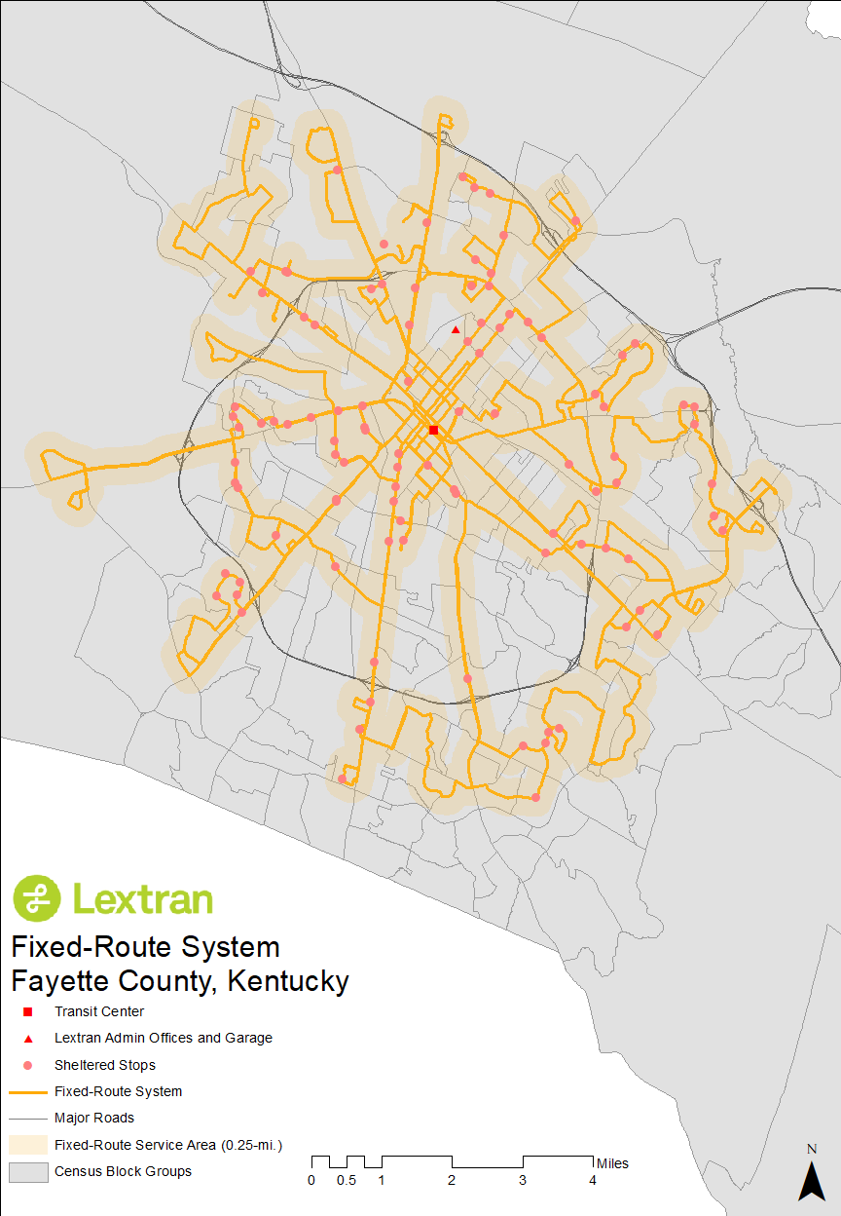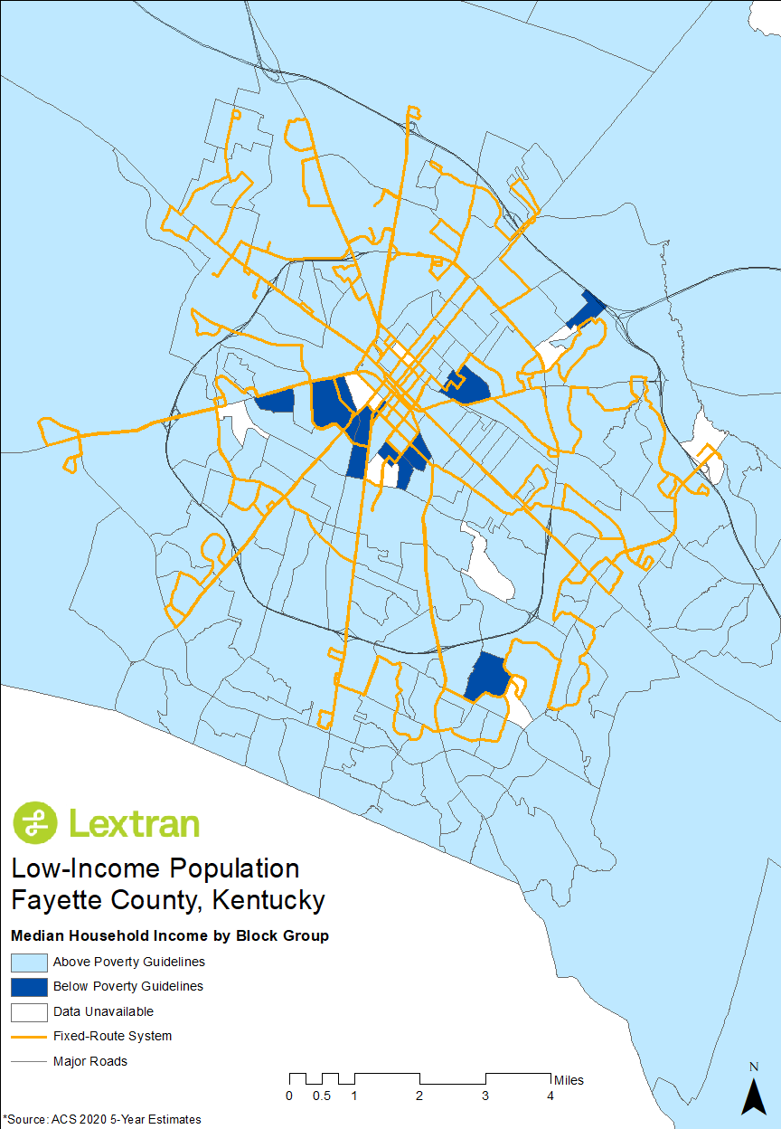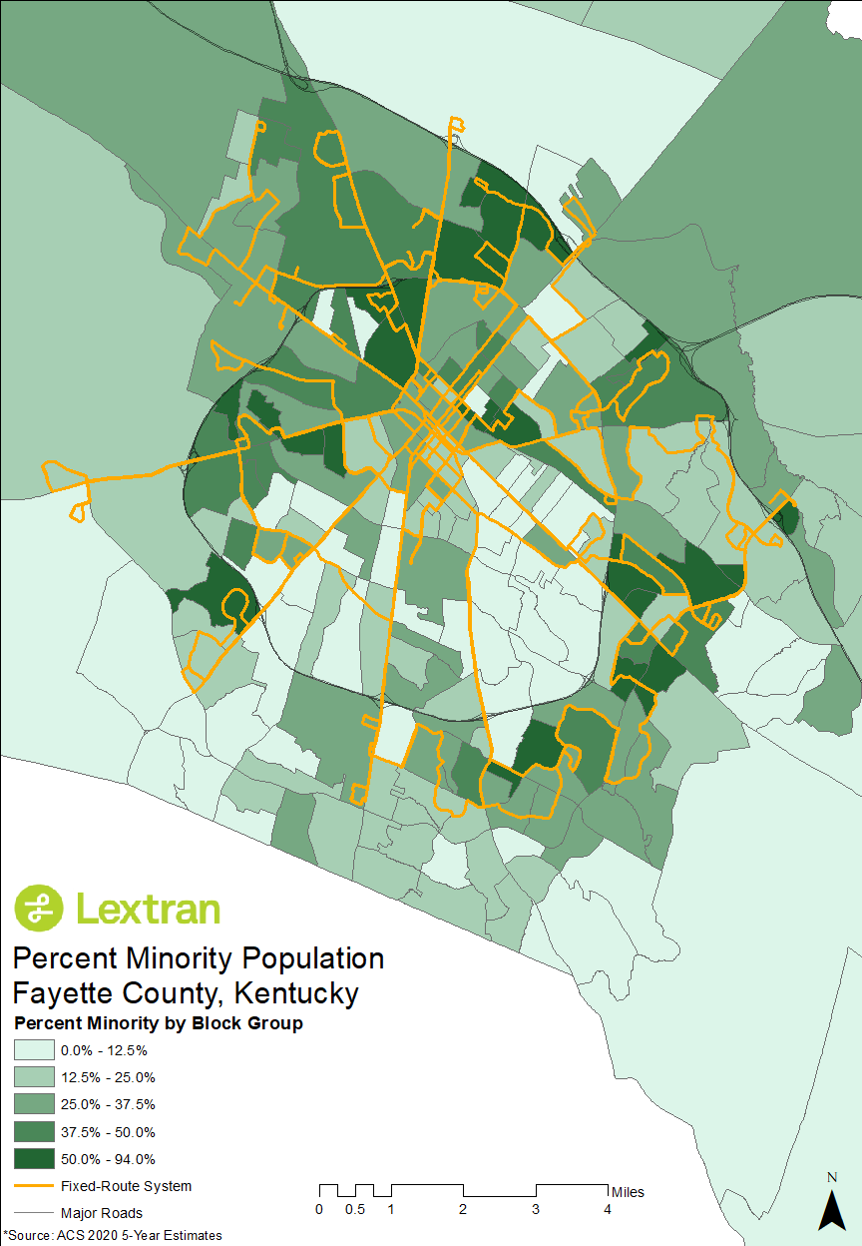

DEMOGRAPHIC RIDERSHIP AND TRAVEL PATTERNS
Demographic ridership and travel pattern data was also collected by ETC Institute. About 36 percent of the survey responses came from African Americans and 51 percent from white/Caucasians, which combined accounted for roughly 87 percent of the survey.
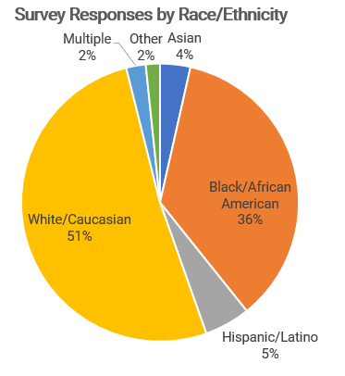
Figure 1: Demographic Ridership (ETC Institute 2021)
The majority of Lextran riders use the fixed-route service for commuting to and from work. More than half of minority and non-minority riders cited work as their primary trip purpose. Trip purposes were roughly equivalent between minority and non-minority passengers with the exception of trips to school/college, where the survey found a larger share of non-minority passengers.

Figure 2: Trip Purpose (ETC Institute 2021)
Nearly half of survey respondents rode Lextran five or more days per week. Non-minority and minority passengers rode Lextran at roughly equivalent frequency. Non-minorities rode Lextran slightly more frequently than minorities at 3-4 days a week, 5 days a week, and 6-7 days a week.

Figure 3: Trip Frequency (ETC Institute 2021)

REQUIREMENT TO MONITOR TRANSIT SERVICE

ROUTE MONITORING PROGRAM
Metric | Route Functional Classification
Passengers per Revenue Hour | Core | Circulator | Limited
Good | More than 22 | More than 15 | More than 10
Satisfactory | Between 11 - 22 | Between 7 - 15 | Between 4 - 10
Unsatisfactory | Less than 11 | Less than 7 | Less than 4
Passengers per Revenue Mile | Core | Circulator | Limited
Good | More than 1.5 | More than 1.2 | More than 1
Satisfactory | Between 0.7 - 1.5 | Between 0.4 - 1.2 | Between 0.3 - 1
Unsatisfactory | Less than 0.7 | Less than 0.4 | Less than 0.3
Farebox Recovery Ratio | Core | Circulator | Limited
Good | More than 15% | More than 10% | More than 8%
Satisfactory | Between 11 - 15% | Between 4 - 10% | Between 4 - 8%
Unsatisfactory | Less than 11% | Less than 4% | Less than 4%
Net Cost per Passenger | Core | Circulator | Limited
Good | Below Average | Below Average | Below Average
Satisfactory | Equal to or Above | Equal to or Above | Equal to or Above
Unsatisfactory | 1 Std. Dev. Above | 1 Std. Dev. Above | 1 Std. Dev. Above
Lextran regularly evaluates the performance of individual routes by route functional classifications. Route performance includes ridership as well as more detailed measures of efficiency and effectiveness. Particular attention is paid to the number of passengers per hour, the number of passengers per mile, the farebox recovery ratio, and the net cost per passenger. Routes that consistently score as unsatisfactory will be further evaluated for ways to improve operational efficiency and effectiveness.
Table 8: Lextran Service Standards by Route Functional Classification
System and route monitoring are conducted monthly and included in Lextran’s Board of Directors meeting packets, which are available publicly at www.lextran.com, Figure 4 is an example.

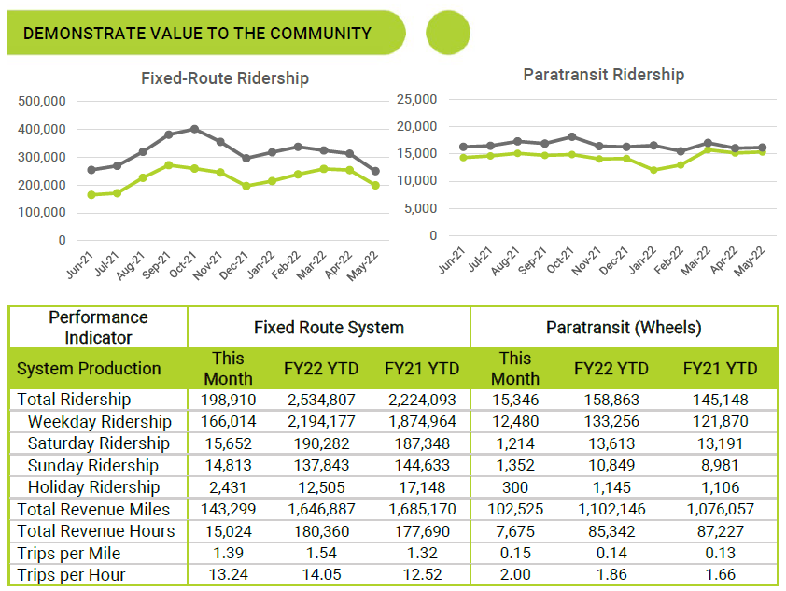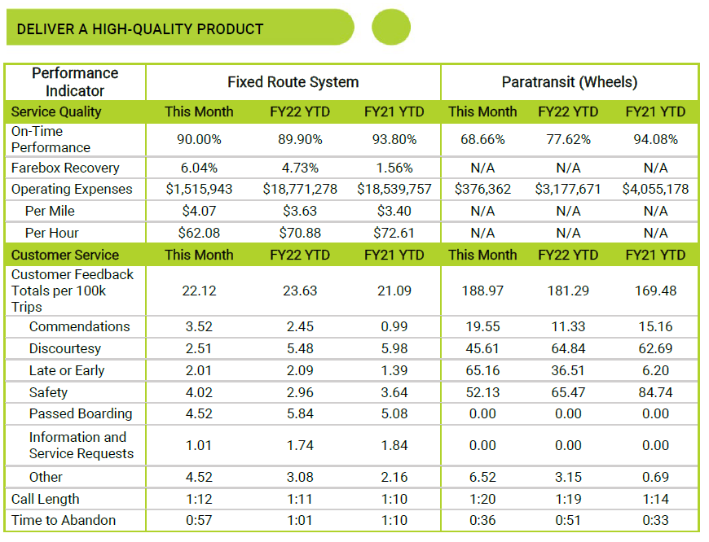
Figure 4: Example Performance Report

REQUIREMENT TO EVALUATE SERVICE AND FARE CHANGES
All proposed service changes are subject to equity analyses. Lextran conducts equity analyses on service change ideas to help guide those ideas into becoming proposed service changes. When proposed service changes are deemed significant enough to be major service changes, the major service change policy goes into effect.

MAJOR SERVICE CHANGE POLICY
Any service change that impacts 25 percent of the revenue-service miles or hours of a route is defined as a major service change. A proposed major service change requires a service equity analysis, including a disparate impact analysis and a disproportionate burden analysis.
Any proposed fare increase is considered a major service change and must also undergo a service equity analysis, including a disparate impact analysis and a disproportionate burden analysis.

DISPARATE IMPACT POLICY
Any and all proposed major service changes must include a disparate impact analysis. A disparate impact analysis determines whether members of a race, color, or national origin are affected more than members of another race, color, or national origin. A disparate impact occurs when a major service change impacts a minority population more than plus or minus 20 percent of the non-minority population.

DISPROPORTIONATE BURDEN POLICY
Any and all proposed major service changes must include a disproportionate burden analysis. A disproportionate burden analysis determines whether members of a low-income group are affected more than the rest of the population. A disproportionate burden occurs when a major service change impacts a low-income group more than plus or minus 20 percent of the non-low-income population.

FINDING A DISPARATE IMPACT OR DISPROPORTIONATE BURDEN
It is Lextran’s policy to avoid, minimize, and mitigate any service changes that are found to be in violation of the disparate impact or disproportionate burden policies. Any proposed service change that violates the disparate impact or disproportionate burden policies will be revised and reevaluated to determine equitable alternatives. Lextran may proceed with a major service change that causes a disparate impact or disproportionate burden if there is substantial legitimate justification for the proposed service change and there are no alternatives that would decrease the disparate impact or disproportionate burden while accomplishing the goals of the service change.

CONDUCTING A DISPARATE IMPACT OR DISPROPORTIONATE BURDEN ANALYSIS
To determine a disparate impact or disproportionate burden, Lextran will follow guidelines set forth in FTA Circular 4702.1B using data from the United States Census Bureau and ridership data. Data analysis will be conducted in a geographic information systems platform and reported through maps and tables.

DEFINITIONS OF MINORITY POPULATIONS
For the purposes of disparate impact and disproportionate burden, Lextran follows the FTA Circular 4702.1B in defining minority populations. Low-income populations follow the poverty guidelines set forth by the Department of Health and Human Services (DHHS).

SERVICE EXPANSION POLICY
Expansion of the Lextran fixed-route system can stem from the following:
- Lextran Comprehensive Operations Analysis
- Lexington Area Metropolitan Planning Organization Long Range Transportation Plan
- Requests for service request
- New generator locations, origins, and destinations

ON-GOING EVALUATION
In addition to the monthly review of individual routes, an annual comprehensive system review is conducted to identify trends in route performance. Routes that perform exceptionally or poorly are reviewed in depth to determine action items to be considered that might include route expansion, consolidation, or alteration. Other actions can be taken to improve an underperforming route, such as increased and targeted marketing or minor service tweaks.

APPENDIX A – BOARD RESOLUTION APPROVING THE TITLE VI PROGRAM PLAN

APPENDIX B – CERTIFICATIONS AND ASSURANCES

APPENDIX C – TITLE VI COMPLAINT FORM-ENGLISH, SPANISH, AND CHINESE
